Is salt bad for plants?

Volunteer guidance (KS1 and 2)

Key Stages
- Key Stage 1 comprises Years 1 and 2, with pupils aged between 5 – 7
- Key Stage 2 comprises Years 3 – 6, with pupils aged between 7 – 11

SESSION 1

Introduction

- Hand out the name stickers (if used) and ask the pupils to write their first names on them. You can wear one too! Try to use the pupils’ names whenever you’re talking to them.

- Introduce yourself and your team to the group. You can talk briefly about the university and what you all do there. You could ask if they know the link between the characters in the ‘Monster Inc’ movies and the University of Birmingham – it’s rumoured that the Monster University was based on UoB – note the clock tower! Slides 1 – 3 can be used here. Bear in mind that many younger students may not be aware of what universities actually are, so you could begin by asking the children what they know about them. This would also be a useful way to break the ice. Based upon their responses, you could discuss the following:

- University is like a big school that you can go to once you’ve finished normal school.
- People normally go to university when they are 18.
- You can go to a University in Birmingham, or in another part of the UK, or another country in the world!
- At University there are lots of different types of science you can learn about. You could learn to be a doctor or you could learn how to design buildings and bridges, or how to build new types of robots, or space rockets, or how to make new medicines to cure people! It’s nice to involve the children, ask them what they’d like to learn about!
- You can then tell them about the particular areas which you are involved with. Use very simple language.

- At this stage, you can ask the pupils to complete the 3 survey sheets regarding their attitudes towards science.

- Introduce the project. Don’t mention ‘toxicology’; instead say that we are going to investigate which things stop plants from growing.

The science of seeds

Start by asking the pupils about what plants need to grow. In Year 2, pupils start learning about how seeds and bulbs grow into plants and that plants need water, light, air and nutrients from the soil. They will also have been taught about habitats and environments and (from Year 4) will have learned that these can change – often as a result of human impact – which can sometimes pose dangers to living things.

You could ask them how things that are bad for plants might get into soil. During the winter for example, salt is used to get rid of snow and ice. Does salt affect the growth of plants? This is what we are going to investigate!

The pupils may well have grown cress from seeds when they started learning about plants. You can show them what these seeds look like before discussing the actual experiment (perhaps a close-up view on a PowerPoint slide). They could even hold some seeds in their hands - do they know what’s inside these tiny seeds?

Describe how a seed is like a tiny parcel. It contains everything a new plant needs to start growing. This picture is taken from BBC Bitesize:
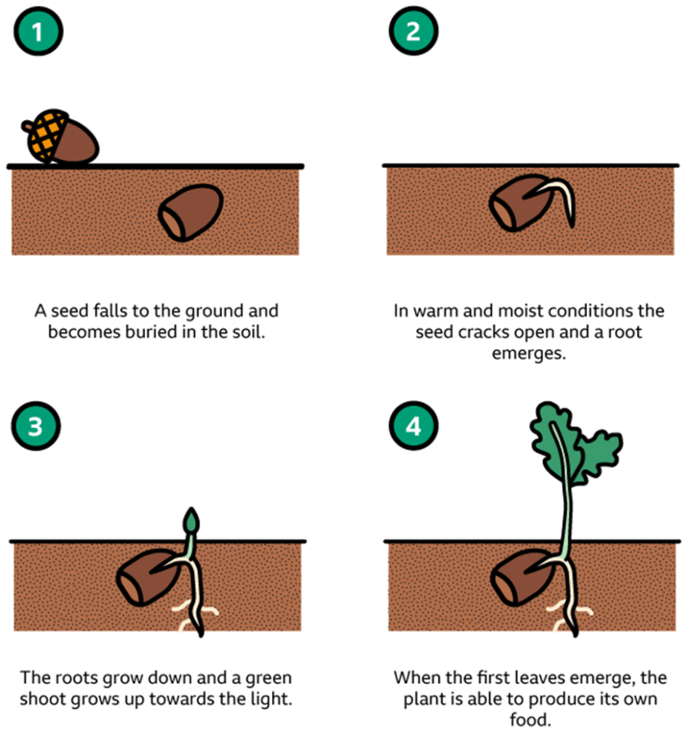

When your cress seeds germinate, they will send roots down to take up water and nutrients – but what if there is something poisonous in the water…?

Introducing the experiment

Show / discuss the experimental set up, with the four different pieces of filter paper in the tray. Each tray will also contain a small beaker of cress seeds.

Each piece of filter paper will be soaked in salt water of different concentrations.

At this stage, the pupils could label each piece of paper with ‘0, ‘low’, ‘medium’ and ‘high’. This describes how much salt there will be.

Describe how we will place 10 seeds on each piece of filter paper, and leave them for a week to germinate…

Variables and controls

- In years 3 and 4 (lower KS2), pupils begin to carry out simple fair tests.
- In years 5 and 6 (upper KS2), they may begin to use the term variables (it’s worth checking with the member(s) of staff to see if the children have used this word yet). They also begin to explain which ones need to be controlled and why.

Ask the pupils to think about:
- What we are going to change (amount of salt)
- What we are going to measure (see what they come up with here – if their ideas are limited to “how many seeds grow”, ask them if there is something they can measure. The presence of the ruler might help here!)
- What we need to control / keep the same (type of seed, number of seeds on each piece of paper, how much they are spread out, amount of water used (they may be familiar with the terms capacity and/or volume), time we leave the seeds to germinate, amount of light – we will leave the trays in a dark place to control this.

This would be ideal for discussion in small groups with your help and prompting. Having the apparatus there in front of them is really helpful, otherwise they may find this too difficult.

Mention that you need to think about exactly the same things when you are planning and carrying out experiments at university! It’s a vital part of ‘working scientifically’.

Predictions

Pupils aren’t expected to do this until they reach Key Stage 3, but it’s definitely worth a try with this experiment. Again, you can talk to them about how this is part of working scientifically.

You may wish to ask the groups to raise their hands in order to indicate which set of seeds they think will grow most successfully. There are opportunities for some interesting discussions here. Given that they may know that salt is a nutrient – and that plants need nutrients – will some predict that the ‘low’, ‘medium’ or even ‘high’ concentration will work best? Encourage the pupils to give reasons for their predictions.

Pupils start to learn about ‘eating the right sorts of food’ in Year 2. So they may already have learnt (at school and/or at home) about the dangers of eating too much salt. Will this be true for plants as well? Can scientists use experiments with plants to investigate the effect of substances on humans?

Aim and method

Discuss what these words mean. Pupils can begin to write about them on their worksheets.

Carrying out the experiment

Check that the pupils are using the correct concentration for each piece of filter paper. I suggest one volunteer stands by the beakers and gets each group or pair to come up to the beakers at a time.

Pupils can continue to write about their aim and method while they are waiting. There is a wordsearch at the end of the worksheet if required.

The pupils will probably find it easier to pick up the cress seeds if they empty the beaker of them onto their worksheet – encourage them not to pour them all out though, as this can lead to spillages!

Remind them to count out exactly 10 cress seeds for each piece of filter paper.

There are two different ways of storing the experiments for the subsequent lesson, depending on availability of resources:

- Students use small trays (holding one group’s pieces of filter paper). This is the preferred method, as the seeds are less likely to dry out.

Ask them why we need to cover the tray with another one and then cover them with a bin bag.
They can stick their name tags to the top tray to identify which one belongs to them.
Adults should take the trays and use Sellotape to attach them together (a couple of small pieces should be sufficient).
The trays can then be left in a dark place. It’s for the adults to do this to avoid overcrowding.

- If students are using larger Gratnell trays (holding two groups’ pieces of filter paper):

Ask them why we need to cover the tray with clingfilm and then place it in a bin bag. (Note that it is useful to place a small beaker of water in the tray to help avoid the seeds drying out. The base of the beaker can be sellotaped to the tray to avoid
spillages.)

They can stick their name tags to each half of the tray to identify which sets of seeds belongs to them. Students could also use a Sharpie pen to divide the tray into two sections, one for each set of pieces of filter paper.

Adults should take the trays and cover them in clingfilm (after adding the small beaker of water to each).
The trays can then be left in a dark place. It’s for the adults to do this to avoid overcrowding.

Finishing off

Congratulate the pupils on their attitude and tell them how much you’ve enjoyed working with them (hopefully you have!)

Give a brief description of what you will be doing next time – looking at the different pieces of paper and seeing how well the cress seeds have grown on each one, before drawing some graphs to display their results.

SESSION 2

Introduction

- Greet the students and tell them how well they worked last time. Give a brief reminder of what they did last time and an overview of what they’ll be doing today – looking at what has happened to the different seed sets and using graphs to present their results. They’ll really be looking forward to seeing what’s happened to their seeds!

- Pupils first begin to use bar charts in Year 3; they don’t draw and use line graphs until Year 6, at the earliest. Do tell them about the importance of using graphs to make the results of your experiments clearer to understand – pictures are easier than tables of numbers!

Results

- Collect the trays. The adults should do this to prevent overcrowding and jostling. Students’ names should be on a Post-It or sticker on the top tray.

- Ask the group to predict what has happened – which set of seeds will have grown most successfully? Again, this could be done via a show of hands.

- By now, they will be desperate to see what’s happened! Remind them to be sensible when you place the tray down…there’s sure to be a lot of excited discussion. Allow them a little time for this before refocussing.

- Remove the top tray and compare their predictions to the results. The different pieces of paper can then be shared out – remind the students to be careful with these. Explain how they will complete the results worksheet. You could make up a number for a particular set of seeds and show how this will be recorded on the table and graph.

Note: even if a seed has only split open a little bit, with a tiny bit of white root showing, they can count it as having germinated.

Graphs

- The group should share results for the four sets of seeds and complete their results table and graph. Slides 3 and 4 can be used to show them how to produce the graph.

Discuss the conclusion with individual groups where possible; this can lead to the discussion about the second graph (see note below).

Note: In most cases (unless the seeds have dried out), there is likely to be a fairly similar number of germinated seeds for each concentration (though the shoot lengths will be very different). This is a useful starting point for discussion with the class or small groups about how they could produce a graph which would show the results more clearly.

- Discuss the conclusion then introduce the drawing of the second graph to the whole group. Slides 5 and 6 can be used here.

- Pupils measure the length of the roots. The rulers provided may not have mm divisions, but their approximate lengths are sufficient, and the children can estimate where their bars should finish on the second graph – this is quite a useful skill.

Keep an eye on how well the pupils are doing and help when needed – ideally, you want to avoid one group finishing well in advance of the others, but this could occur. Discuss the second graph with any groups / individuals who do finish quickly. They can then continue with the wordsearch or move onto one of the additional activities (see below).

Conclusions

Once all the graphs for each group are complete, encourage them to compare their results.

Finishing off

Volunteers should collect in trays. Clingfilm, filter paper, seeds and shoots can be disposed of. If possible, give any damp trays a wipe to dry them off.

Ask pupils to complete the survey sheets about attitudes toward science; this could also be done during the additional activities below.

Additional activities

A: Experiment 2

Note: Although the original intention was for pupils to perform a second experiment involving household chemicals of their choice, it’s unlikely that there will be enough time left in the second lesson to do this. Instead, pupils can do the activities about animal and plant cells (see details below). I’ve retained the guidance notes for the experiment here in case a third lesson is available.

Planning

The pupils can now decide what they are going to investigate next – show them the range of other household chemicals and tell them that they are going to repeat their experiment using any of these they want.

They can compare the effect of different substances on their seeds or vary the concentration of them.

There is no need to measure different concentrations as this is likely to be too time consuming.

Slides 8 and 9 of the PowerPoint can be used to help introduce the experiment.

Carrying out the experiment

The pupils can use the same trays as before – make sure that the used pieces of filter paper are thrown away first.

Pupils are likely to need careful supervision to avoid unnecessary mess!

Trays should be stored as before – they can analyse their results with their class teacher in a later lesson.

B: Animal and plant cells

- Introduce the idea of cells (see slide 10). Note that KS1/2 students will not have studied cells at all.

- Briefly discuss how and why scientists use plants to investigate and predict the effects of chemicals on animals. At this stage, you can limit discussion to the idea that all living things are made of cells, which have similarities as well as differences. Students will already be aware that scientists can group living things according to these criteria – for example, the different classes of vertebrates and invertebrates.

- Dependent on time remaining, there are a number of activities which pupils can attempt.

- Show the models of plant and animal cells – groups of students can examine these and identify parts which appear in both.
- Slide 12 features a hyperlink to a short (2.45 minute) video about plant and animal cells. This could be used in conjunction with (a) so that pupils can check their answers.
- The ‘Plant and Animal Cells’ worksheet asks students to identify each type of cell and label the various parts. Answers are on slide 13.

The ‘Plant Cell Functions’ sheet has explanations of the role of the different parts. This is for information only – it’s probably a little too early to ask pupils to study this in detail.

- The hyperlink on slide 14 takes you to a BBC Bitesize page about cells. There are various activities which can be presented to the class – the most suitable are the ‘Animal Cell Structure’ and ‘Plant Cell Structure’ ones (about halfway down the page).

